1. **Auto Trace & Explain Plan**

|  |  |  |
| --- | --- | --- |
| № | Auto Trace Configuration Options | Expected Results |
| 1 | set autotrace off | Result set |
| 2 | set autotrace on | Result set, Execution plan, Statistics |
| 3 | set autotrace traceonly | Execution plan, Statistics |
| 4 | set autotrace on explain | Result set, Execution plan |
| 5 | set autotrace on statistics | Result set, Statistics |
| 6 | set autotrace on explain statistics | Result set, Execution plan, Statistics |
| 7 | set autotrace traceonly explain | Execution plan |
| 8 | set autotrace traceonly statistics | Statistics |
| 9 | set autotrace traceonly explain statistics | Execution plan, Statistics |
| 10 | set autotrace off explain | Result set |
| 11 | set autotrace off statistics | Result set |
| 12 | set autotrace off explain statistics | Result set |

AUTOTRACE is a utility in SQL* PLUS, that generates a report on the execution path used by SQL optimizer after it successfully executes a DML statement. It instantly provides an automatic feedback that can be analyzed to understand different technical aspects on how Oracle executes the SQL. Such feedback is very useful for Query tuning.

There are 3 options, which are available to be watched by autotrace: “Result set”, “Execution plan” and “Statistics”. All this commands turn off or on some of mentioned options in different combinations. Also the autotrace itself could be turned off totally.

# Join Methods

**Nested Loops Joins**

SELECT *

FROM emp e, dept d

WHERE e.deptno = d.deptno

AND d.deptno = 30;

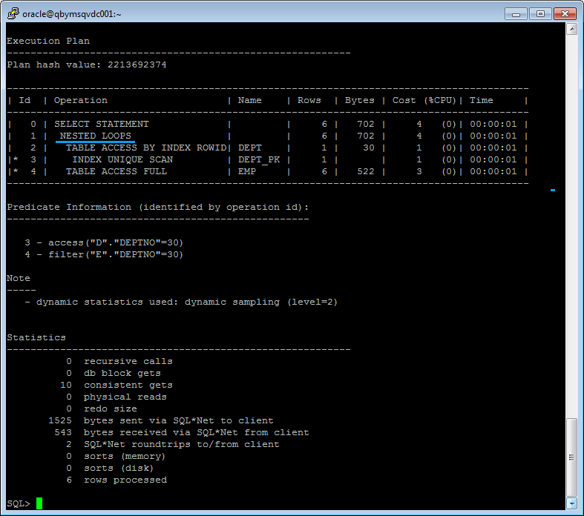

**Sort-Merge Joins**

SELECT *

FROM emp e, dept d

WHERE e.deptno = d.deptno;

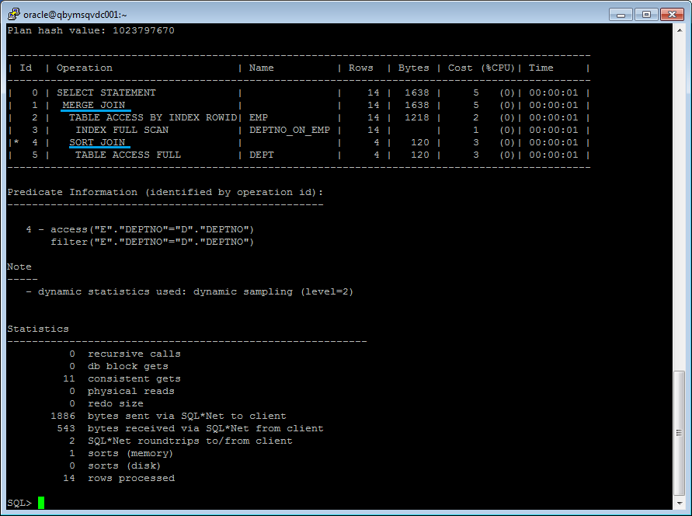

**Hash Joins**

SELECT *

FROM emp e JOIN dept d USING (deptno)

WHERE deptno > 10;

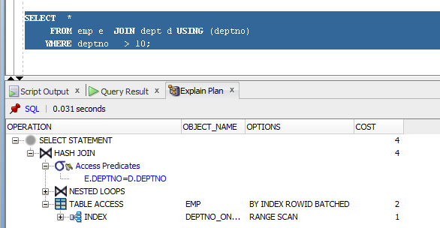

**Cartesian Joins**

SELECT *

FROM emp e, dept d;

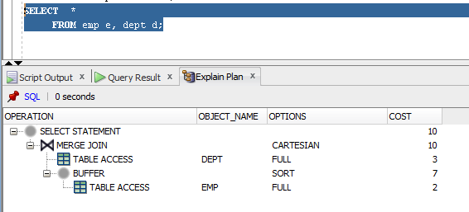

**Left/Right Outer Joins**

SELECT *

FROM emp e LEFT OUTER JOIN dept d USING (deptno)

WHERE deptno = 10;

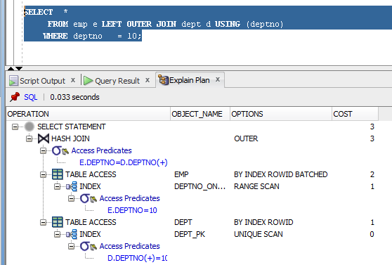

SELECT *

FROM emp e RIGHT OUTER JOIN dept d USING (deptno)

WHERE deptno = 10;

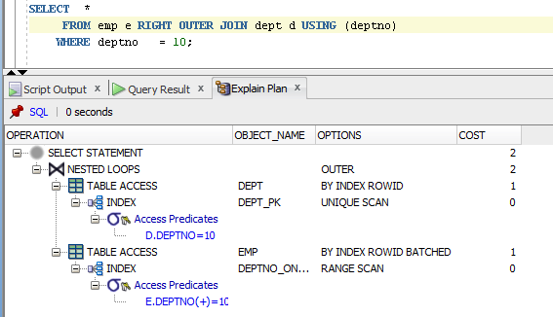

**Full Outer Join**

SELECT *

FROM emp e FULL OUTER JOIN dept d USING (deptno)

WHERE deptno = 10;

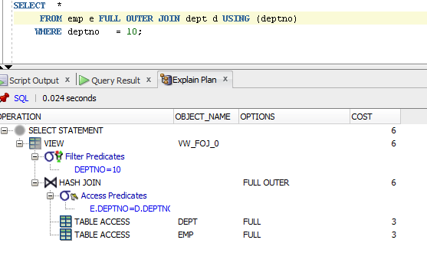

**Semi Joins**

SELECT *

FROM dept d

WHERE EXISTS (

SELECT *

FROM emp e

WHERE e.deptno = d.deptno);

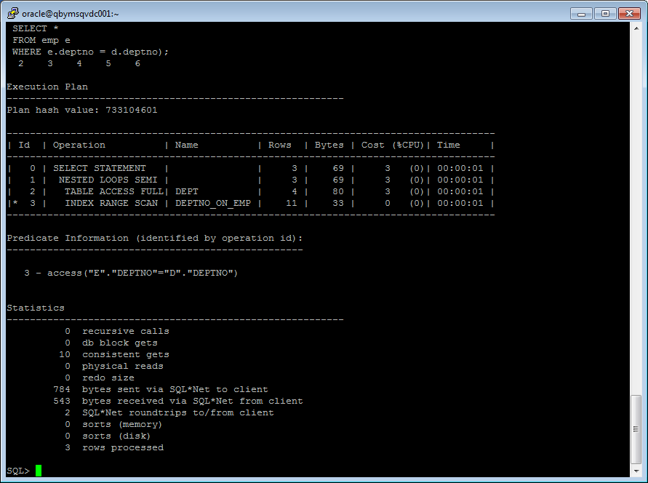

SELECT *

FROM dept d

WHERE EXISTS (

SELECT /*+ MERGE_SJ*/ *

FROM emp e

WHERE e.deptno = d.deptno);

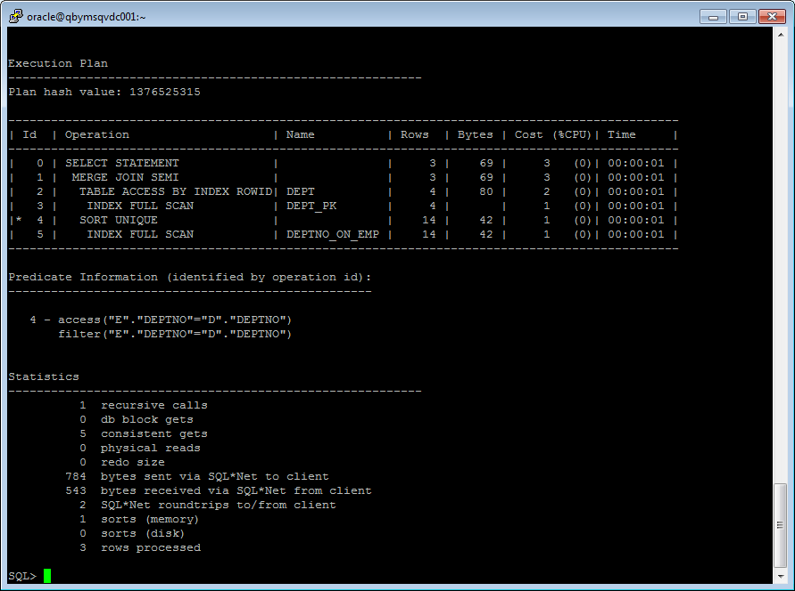

SELECT *

FROM dept d

WHERE EXISTS (

SELECT /*+ hash_SJ*/*

FROM emp e

WHERE e.deptno = d.deptno);

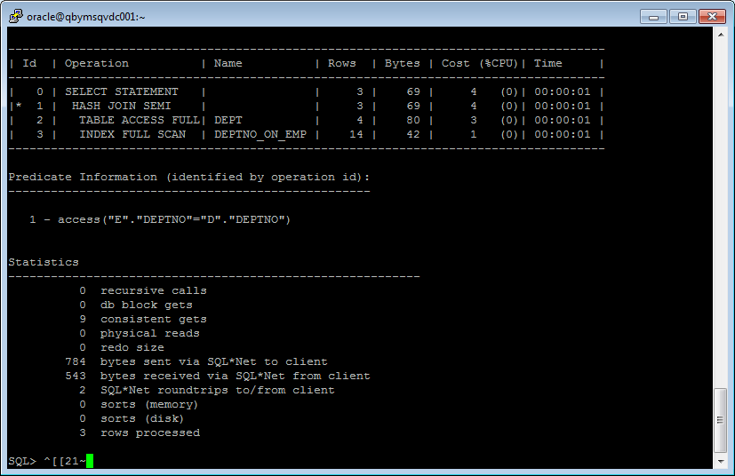

**Anti Joins**

SELECT *

FROM dept d

WHERE NOT EXISTS (

SELECT *

FROM emp e

WHERE e.deptno = d.deptno);

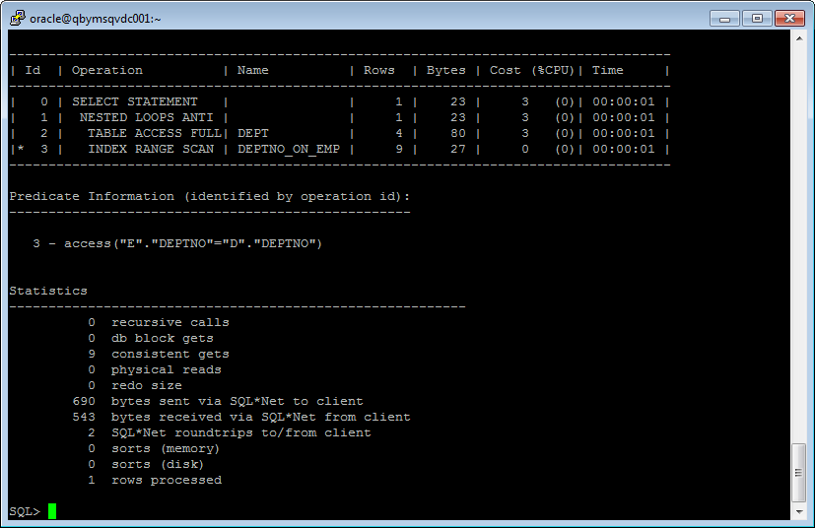

SELECT *

FROM dept d

WHERE NOT EXISTS (

SELECT /*+ HASH_AJ*/*

FROM emp e

WHERE e.deptno = d.deptno);

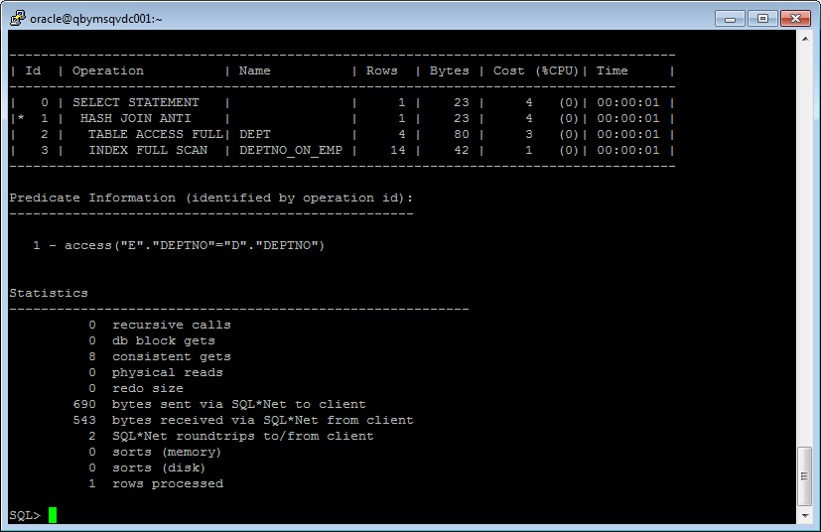

SELECT *

FROM dept d

WHERE NOT EXISTS (

SELECT /*+ MERGE_AJ*/*

FROM emp e

WHERE e.deptno = d.deptno);

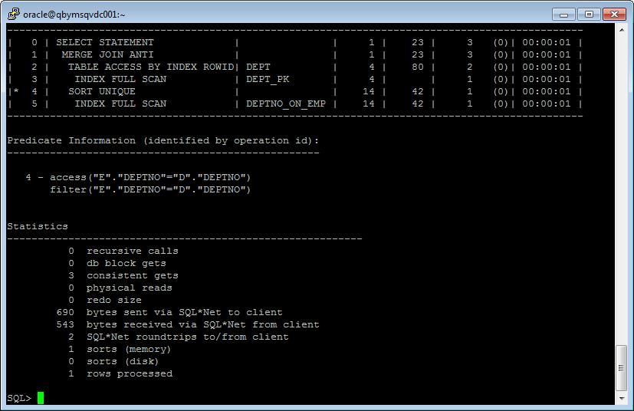

**Task 10: Prepare summary table**

Signs of performance:

* “+”– the best performance;
* “+-” – good performance;
* “-+” – not so good performance;
* “-” – the worst performance.

|  |  |  |  |  |  |  |
| --- | --- | --- | --- | --- | --- | --- |
| **Join Access “A”** | **Join Access “B”** | **Nested Loop** | **Hash Join** | **Sort-Merge Join** | **Anti-Join** | **Semi-Join** |
| Heap Table (S) | Heap Table (S) | + | +- | +- | + | + |
| Heap Table (S) | Heap Indexed Table (S) | + (unique scan, range scan) | + | +- | + | + |
| Heap Indexed Table (S) | Heap Indexed Table (S) | + (unique scan, range scan) | + | + | + | + |
| Heap Table (L) | Heap Table (L) | - | -+ | - | - | - |
| Heap Table (L) | Heap Indexed Table (L) | -+ (unique scan, range scan) | -+ | +- | - | - |
| Heap Indexed Table (L) | Heap Indexed Table (L) | +- (unique scan, range scan) | -+ | + | - | - |
| Heap Table (S) | Heap Table (L) | -+ | + | -+ | +- | +- |
| Heap Table (S) | Heap Indexed Table (L) | +- (unique scan, range scan) | + | +- | +- | +- |
| Heap Indexed Table (S) | Heap Table (L) | -+ (unique scan, range scan) | + | +- | +- | +- |
| Heap Indexed Table (L) | Heap Indexed Table (S) | +- (unique scan, range scan) | + | + | +- | +- |